

**LAB FILE**

**Name: Neha T V**

**Branch: B.Tech**

**Section: CSE**

**Course: Source Code Management**

**Topic: Lab file**

**SEN: A86605223001**

**Date of Submission: 06 June 2025**



Amity School of   
Engineering & Technology

**SOURCE CODE MANAGEMENT**

**LAB – 1**

Date: 30 January 2025

* **INSTALLING GIT**

1. <https://git-scm.com/downloads/win>

**COMMANDS**

1. **pwd**

* Present Working directory
* Used to view the current directory working on

1. **cd**

* change directory
* used to change the directory

1. **ls**

* used to list all folders

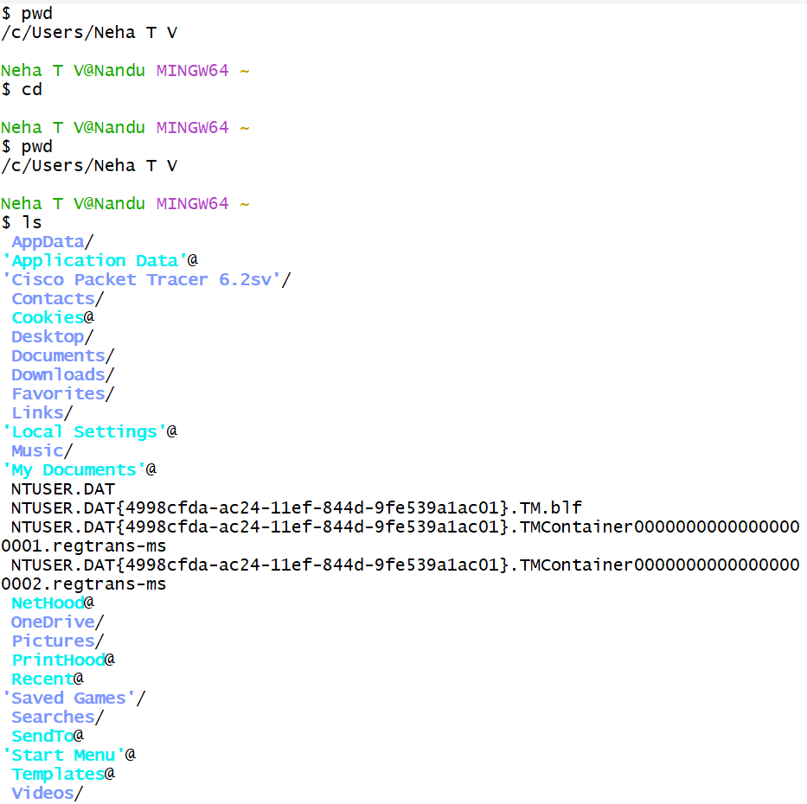

1. **vi**

* vim mode / vi editor
* used to create a file, edit it
* Syntax: vi nameoffile (Ex: vi hello.txt)

click the key i to insert or edit your file. Then esc to return from insert mode :wq (then enter) to return

1. **cat**

* Syntax: cat filename (cat hello.txt)
* to view the file contents.

1. **ls -l**

* Used to list all files

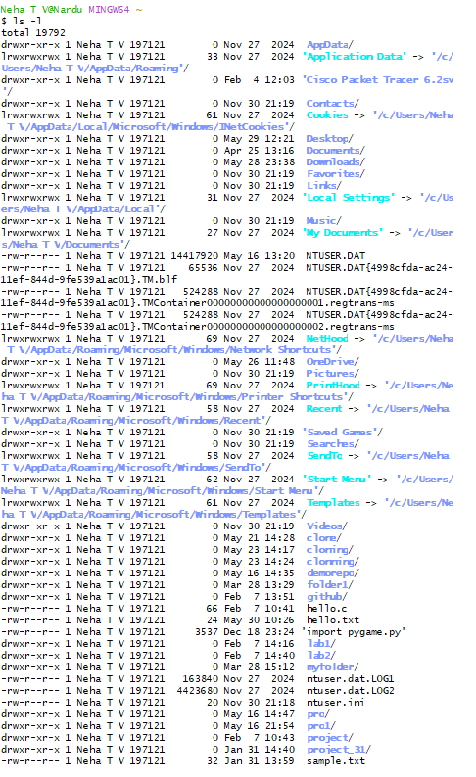

1. **ls -ah**
2. **history**

* used to view history of commands

1. **mkdir**

* used to create folder
* Syntax: mkdir nameoffolder
* ls nameoffolder
* confirmation to check if folder is created
* cd folder/
* to change the present directory as the folder

* also after this create one new file by using vi (then insert i)

1. git config

* Used to configure username and email
* Syntax:

git config –-global user.mail “mail”

git config -–global user.name “username”

1. **git init**

* initialize the repository (important step then only folder will get watched)
* working directory to empty repo.

1. **git add file**

* to add the file
* Syntax: git add filename
* After this edit the file (using vi, insert i)

1. **git commit**

* Used to commit a change
* Syntax: git commit -m “Message”

1. **git log**

* Used to view status / entries of commits in that branch

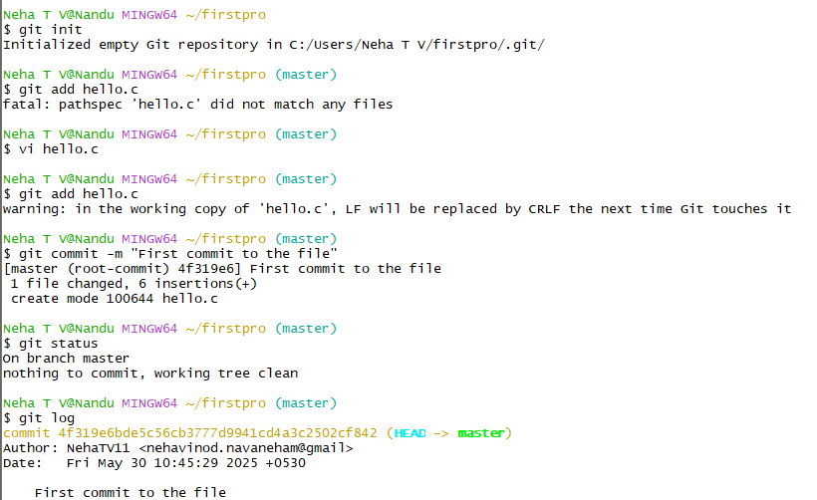

1. git status

* To view status of the branch

**LAB – 2**

Date: 07 February 2025

1. git log –oneline

* To view log statements at once

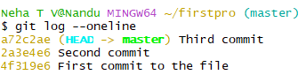

1. git diff commit1 commit2

* By taking numbers of the commit which will be shown in the git log –oneline command, the commits are compared in terms of what is added and what is removed.

1. git add .

* To add multiple files to repo at once



1. git branch <name>

* It is used to create a new branch other than the master branch
* Syntax: git branch nameofbranch (Example: git branch test)

1. git branch

* Used to see the different branches in the repo

1. git checkout branchname

* Used to move to that branch.

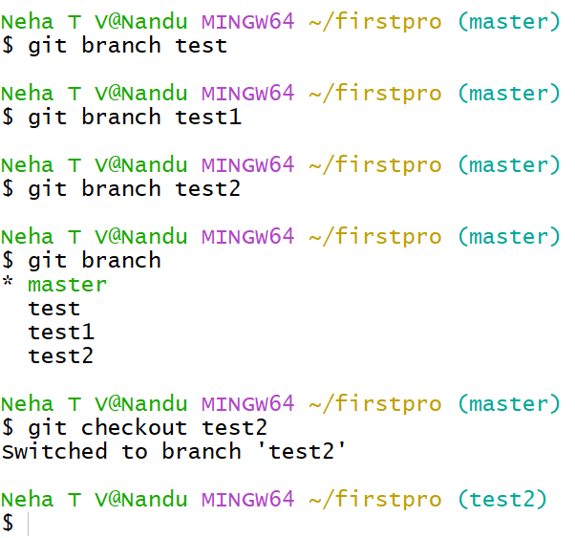

1. git reflog

* Used to see all the commits present in all the branches.

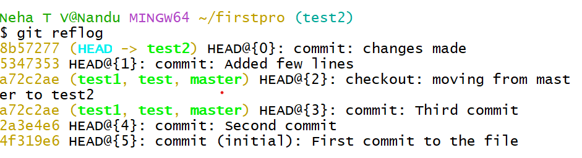

* Even git log works
* 2 different branches will have 2 different codes for the same file. Changes done in one branch will not be reflected in changes done in the other branch.

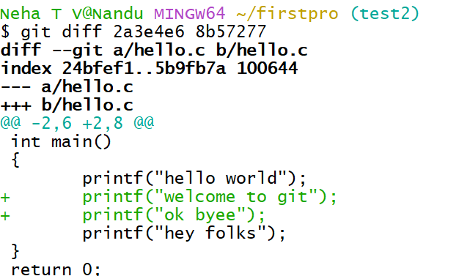

Here, change is done in test2 branch.

The change in file doesn’t appear in the main branch

**LAB – 3**

Date: 14 February 2025

1. Git remote add origin <url of the repository on github.com>

* For that create a repository on github.com after logging on to the website. Use the same id / email address which was used to config in git bash. Create a new repository by giving a name to the repository.

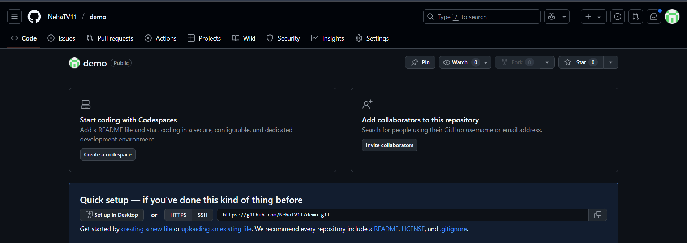

Copy the url of the repository and using the command git remote add origin <link of repo> add the repo on gitbash



1. git push -u origin <branch>

* Used to push the branch to the repo on Github.
* Use the command git push -u origin <nameofbranch> to add it, for the first time authentication will be required then when the page is refreshed that branch and all the files in it gets added.

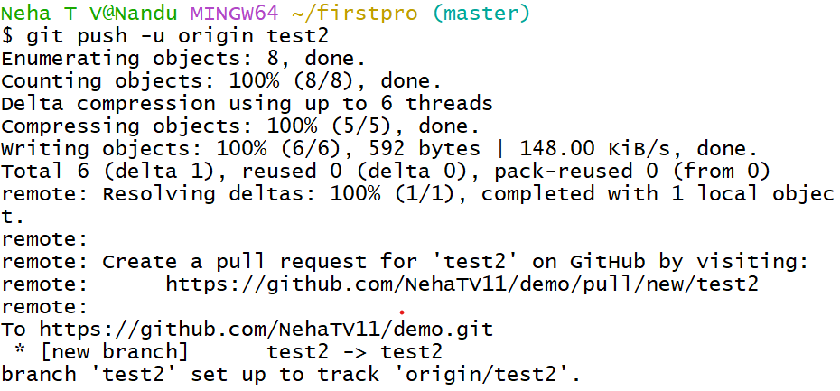

When we add a new branch or any file, a pull request gets created. We need to merge pull request for it to get added after viewing and checking it.

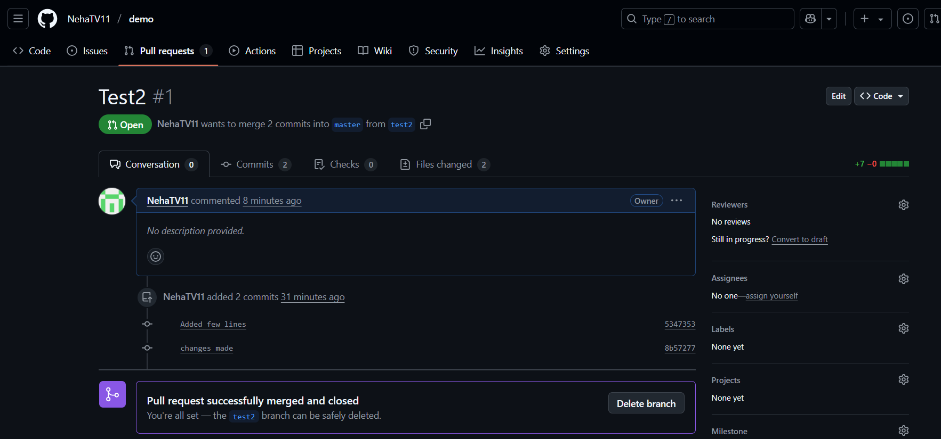

1. **Induce Conflicts, Open and Close Pull Requests** 
   1. **Git Merging & Conflicts:**

* git merge: Integrate changes from one branch into another.

* Conflicts arise during merging when Git cannot automatically reconcile diverging changes.

* Use a merge tool to resolve conflicts.

* git mergetool: Command to launch the configured merge tool.

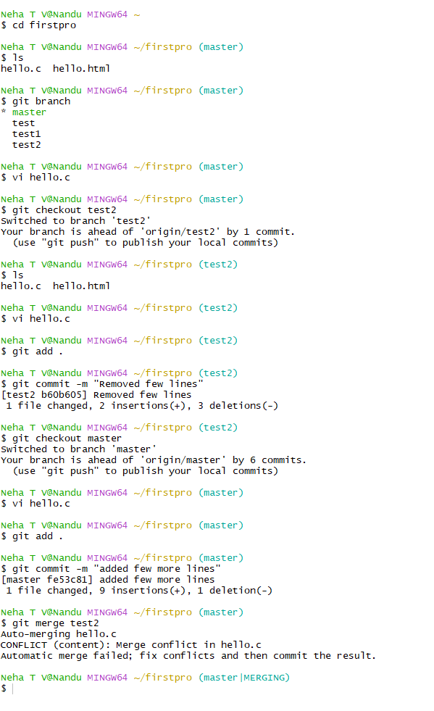

**Gitignore**: *. gitignore file: Specifies intentionally untracked files that Git should ignore.

* Files listed in .gitignore will not be tracked by Git and will not be mirrored on GitHub.

**25. Pull Requests(fork)**: * Opening a pull request

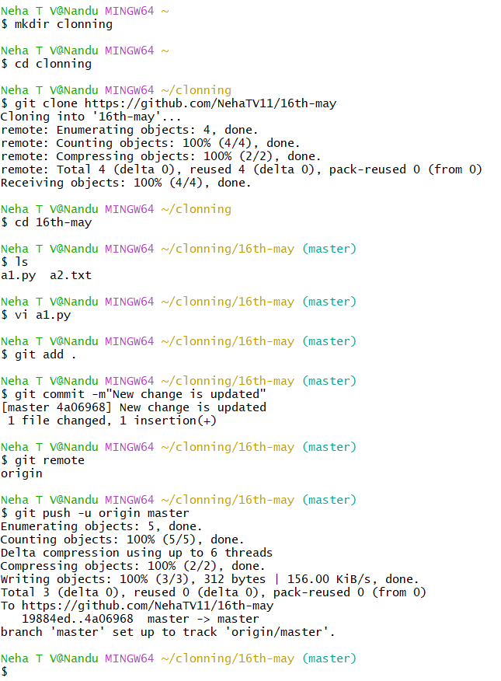

Closing a pull request



